INSTITUTE OF FINANCE MANAGEMENT

FACULTY OF COMPUTING, INFORMATION SYSTEMS AND MATHEMATICS
DEPARTMENT OF COMPUTER SCIENCE
BACHELOR IN COMPUTER SCIENCE
ACADEMIC YEAR 2015-2016
A PROJECT REPORT ON PHARMACY MANAGEMENT SYSTEM (PMS)

NAME REG. NUMBER
NKANABO I. NKANABO IMC/BCS/13/74261
HAMIS, HAMIS S. IMC/BCS/13/74483
MWINGE, HAGAI SAMSON IMC/BCS/13/74442
AMBROSY, EMMANUEL DOMINICK IMC/BCS/13/75513
SALEHE, SAIDA RAMADHAN IMC/BCS/13/65014

SUPERVISOR: DR. IGIRA, FARAJA
SUBMISSION DATE: 31ST JULY, 2016.

IN PARTIAL FULFILMENT FOR THE REQUIREMENTS OF THE AWARD OF BACHELOR DEGREE IN COMPUTER SCIENCE (B.SC).

JULY, 2016

ABSTRACT
To be written at the end…..

ACKNOWLEDGEMENT
It’s our pleasure to extend our sincere gratitude to Almighty God for the knowledge wisdom and understanding that he bestowed on us to carry out this project.

LIST OF ACRONYMS
PMS Pharmacy Management System
ICT Information and Communication Technology
GUI Graphic User Interface
TFDA Tanzania Food and Drugs Authority
PS Pharmacy System
Table of Contents
ABSTRACT ii
ACKNOWLEDGEMENT iii
LIST OF ACRONYMS iv
LIST OF FIGURES vii
LIST OF TABLES viii
CHAPTER ONE 1
1.0 INTRODUCTION 1
1.1 BACKGROUND OF THE STUDY 1
1.2 STATEMENT OF THE PROBLEM 2
1.3 AIMS AND OBJECTIVES 2
1.4 SCOPE AND LIMITATION 2
1.5 RESEARCH METHODOLOGY 3
1.6 CHAPTER LAYOUT 3
CHAPTER TWO 4
LITERATURE REVIEW 4
2.0 INTRODUCTION 4
3.0 1.2 Objectives 5
2 Current System 5
3 Proposed System 6
4.0 3.1 Functional Requirements 6
5.0 3.2 Nonfunctional Requirements 7
3.2.1 Usability 7
3.2.2 Reliability 7
3.2.3 Performance 8
6.0 3.3 Implementation 8
7.0 3.4 System Models 8
3.4.1 Actors 8
3.4.2 Use case model 8
Use case diagram 12

LIST OF FIGURES

LIST OF TABLES
Table 1 hhhhhed

CHAPTER ONE

INTRODUCTION
Pharmacy can be defined as a place where medical are prepared and sold or mechanical process of handling and distributing medications. Dispensing medications in a community pharmacy nowadays is a time consuming operation, unless computerized system is used partially or completely to support those activities. The pharmacist has extra job such as inventory management, report generation, interaction with hospitals, finance and other related systems.
The use of ICT in pharmacy activities supports several business models, including mail order, hospice, long-term care, specialty and likes. Our study focuses on pharmacy store, which mostly that we visited are not using ICT systems in doing routine activities. To name the few, JD Pharmacy, Namanga Day Night, HITO Pharmacy, etc. the ICT system must support the delivery of patient care including the dispensing of drugs in accordance with Tanzania Food and Drugs Authority (TFDA) regulations and standards. PMS must facilitate both information exchange with external systems such as electronic health records systems, business partners such as Health Insurance companies, Mobile payments systems, Hospitals or any other partners. On top of that, PMS must be designed to support the privacy and security of personal health information recorded and stored within and transmitted to and from the systems.
There are number of pharmacy systems exist today. We manage to come across some of them, including ExactVision8 used by JD Pharmacy, Medeil system and FSI Pharmacy Management System. All of these systems have basic function and specific features that differentiate one system to another.
The proposed PMS is also coming with distinguished features that support the existing environments and innovation. Some of the features are to support the use of Health Insurance billing card, Mobile payment, stock reallocation, partners information sharing, stock notification, reports and likes. These features will be explained in proposed system functionalities in this document.

BACKGROUND OF THE STUDY
Depending on the location of the pharmacy store, but most of the store located near hospitals or clinical centers are experiencing huge number of walk in customers throughout the day, this affect the quality of the service provided, prone to human error in dispensing drugs and at large affect the business. The pharmacist work became tedious, customer satisfaction is rarely achieved and inventory control becomes harder to be conducted.
In today’s business strategy, competition is inevitable. Quick and reliable customer service, proper sales and inventory management and the use of ICT in business are essentials factors in prosperity of an organization. Particularly, pharmacist (or any person manage pharmacy) require proper and updated information regarding drugs on stock concerning dispensing, expiring, stock movement and any other essential information related. Hence, raise the need of information database.

STATEMENT OF THE PROBLEM
Pharmacy has kept..

AIMS AND OBJECTIVES
This project aims to develop a computerized system that facilitate management of pharmaceutical store activities and will be able to achieve the following objectives:
- To ensure update information database
- Improve business efficiency through effective control mechanism of services and other activities.
- To simplify pharmacist (sales person) activities.
- To provide optimal drug inventory management by monitoring the drug movement in the pharmacy.
- To provide real time and periodic reports.
- To improve service by providing alternative mode of payments (e.g. Mobile Money)
- Act as information kiosk to provide medical information related to diseases, consumptions, side effects and other related information.

SCOPE AND LIMITATION
PMS is limited to the activities done in pharmaceutical store for the purpose of improving sales, services and quality of the product (drugs). The system will not be able to provide drug prescription, to handle electronic prescription or to keep every customer details (customer details are optional).

RESEARCH METHODOLOGY
The method used to develop PMS can be grouped into four stages, requirement gathering, analysis and design, implementation and lastly testing. Each category was given to some members of the team to dig the insight of the area and propose the better way of completing that part. Interviews were conducted to some pharmacies and the collected data were analyzed and documented for compilation.

CHAPTER LAYOUT
Chapter one consists of Introduction, Background of the study, statement of the problem, aims and objectives, scope and limitation of the system.
Chapter two consists of introduction, literature review of the project, an overview of the current PMS, its benefits and expected features to be added in the system.
Chapter three deal with the analysis of the existing system, under which description of the current system will be analyzed. Challenges of existing system, description of the proposed system and the advantages of the proposed system are also addressed.
Chapter four consist of system design, system implementation and system documentation under the system design, the system design will have the input and output design.
Chapter five will include summary of the project report, conclusion and recommendation based on the research done on the project.

CHAPTER TWO

LITERATURE REVIEW

INTRODUCTION
This chapter…

1.2 Objectives
- Making pharmacy organizations computerized by creating neat work through minimizing or eliminating wasting of time.
- Provide optimal drugs inventory management by monitoring drug movements in the pharmacy units.
- To be able to generate report within a significantly short period of time despites simultaneous usage of database.
- Facilitate accessibility of drugs information and information management, includes searching, delete and updates of medicines (Pharmacist).
- Minimize human error
- Identify medication pattern usage as prescribed (patient).
- Keep tract of customers information

2 Current System
Many of the existing pharmacies in Dar es Salaam use manual operation in conducting pharmacy activities. Some of them are using partial ICT system and manual work, and very few of them are using full computerized system. Manual operation is pure paper based, i.e dispensing of medications, stock recording, receipt recording and stock control. All the necessary information are recorded in a counter book and hence reviewed in daily or weekly bases to check the trend of the periodic reports. This system is very economical that’s why is massively adopted by many pharmacies in our areas. Any person with read and writing capability will be able to use this system, no need of computer knowledge. Apart from above benefits, manual system has many limitations as far as business is concern. First is time consuming and tiresome in stock management. Compilation of daily/weekly manual sales and stock movements, acquisitions and stock auditing takes long time. Since inventory control is manually conducted, then is subjected to human error, which might results into less profitability. Reliability of the system, the pharmacy might run out of stock if it is not practiced regularly.
Some pharmacies use both systems in partially, manual system and computerized systems. Sales activities and purchases are initially done manually. Then the purchased medicines are stored in the computer application (i.e. Microsoft Excel), later on sales are updated to the excel file periodically to generated the sales reports and available stock. Through this system essential information is kept in both papers and computer, hence support backup in case of data loss. Also facilitate extraction of simple reports, such as sales reports, stock availability reports and financial report. There are some limitations regards this way of record keeping, one of them is repetition of task. The sales recording task is done twice, in manual book and computer application. This way increases cost compared to the manual system, since you one has to buy books and computer.
The rest pharmacies use almost fully computerized system. That means point of sales (POS), inventory control, reports and payments. Example of this system is ExactVision8 used by JD Pharmacy. It’s kind of enterprise system that integrate other subsystem of different departments. ExactVision8 system performs all pharmacy activities, payroll activities, accounting activities, and asset control and customer information management. Although the implementation cost is high, the system is very supportive to pharmacist and all vendors involved in daily operation of medications dispensing and handling. Direct system sales and purchases update facilitates instant report generation and extraction. Makes inventory control simplified and support system notification in case of low stock or expire dates of medicines.

3 Proposed System
The requirements of PMS are intended to direct the development and deployment of pharmacy management systems that enable patient care services within pharmacy practice and as such should be ready by anyone involved in the acquisition or use of PMS.

3.1 Functional Requirements
- Point of sale – using capturing devices; keyboard, mouse, barcode reader, etc.
- Accept mobile payment – customer should be able to pay through Mobile money.
- Accept Health Insurance payment card – alternatively costumer should be able to pay through valid Insurance card.
- User identification – to identify the user of the system.
- Access control mechanism – every user has to be granted the required access to fulfill his job
- Generate report – the PMS generates report weekly on information about the drugs and its exports the information as output document.
- Store the necessary information of the drugs – the PMS stores the detail information about each medicine including actual name, formula of medicine and how it is importance and for which disease is required.
- Searching medicines and other data’s – the searching process is based on the name of the given data or the identification of the item.
- Alerting pharmacy data’s in the system – changing system status due to medicine outdated, modifying the saved medicine data for incorrect data, deleting of data’s of the pharmacy can be done on the system.
- Prepare bill for the medicine
- Gives navigation or information for pharmacy organization.
- Create and deactivate/delete user account
- Changing login passwords

3.2 Nonfunctional Requirements

3.2.1 Usability
- User must be able to access the system from different browser. Such as Safari, Opera, Mozilla, Window Explorer, etc
- User must be able to access the system through different computing devices. Such Tablets, Smartphone, laptop, etc.
- Fit into different screen resolutions.
- Web site Organization – that user will not get lost in the website while browsing (navigation).

3.2.2 Reliability
- The system is available based on the user needs, can work properly, and do the transactions efficiently including safe data management of the pharmacy.
- For invalid and malfunctioned operation the system will restart in order to prevent data loose as well as safe operation within 5 seconds.
- The system is password protected to change things on the system.
- Any user cannot use the system but the guest user can see on the general properties of the pharmacy and medicine without password.

3.2.3 Performance
- GUI speed up user navigation and operates its function in small amount of time.
- Session controls user login/logout trend.
- Browser verification forms to protect database.

3.3 Implementation
- Project will be implemented using PHP framework language and bootstrap.
- All project graphical user interfaces will be created using an html” Sublime Text 3 editor.
- Database will be developed in MySQL.

3.4 System Models

3.4.1 Actors
Pharmacy manager – controller of PMS, can create user, register medicine, update medicines, delete and run reports.
Pharmacist – registered user of PMS can view medicines, sell medicines and print receipt.
Customer – any guest user (unregistered) who can view general properties of the pharmacy and medicine without password.
Business partner – a user that agrees to access PMS information legally based on the terms and conditioned agreed.

3.4.2 Use case model
Name: | CreateUser
Actor: | Pharmacy Manager
Entry  Conditions: | Login.
Flow of  Events: | - Open manager home page  - Select ‘Add user’ form  - Fill the form with personal details  - PMS verify user’s inputs data format.  - Form submitted.
Exit  Conditions: | Registered.

Name: | UserLogin
Actor: | All Users
Entry  Conditions: | Registered user.
Flow of  Events: | - USER select login form  - Insert username and password.  - SYSTEM verifies user inputs formats.  - SYSTEM verifies USER’s details against the database data.  - USER login successful.
Exit  Conditions: | Logon.

Name: | StockNotification
Actor: | Pharmacy Manager, Pharmacist
Entry  Conditions: | Log in the system
Flow of  Events: | - Select reports  - View available stock  - System triggers notification.  - Notification display in users page
Exit  Conditions: | User’s home page.
Name: | SellMedicine
Actor: | Pharmacist
Entry  Conditions: | USER login.  Prescription
Flow of  Events: | - Customers provide prescription.  - Pharmacist log the prescription details  - Pharmacist dispense drugs  - Issue bill
Exit  Conditions: | Bill output, ready to pay

Name: | ReceiveMobilePayment
Actor: | Pharmacist
Entry  Conditions: | Login on POS.
Flow of  Events: | - Customer sends mobile money to system number.  - System generates unique number (code no.) and send to customers.  - Pharmacist enters unique code no to PMS  - Money Transaction is confirmed by the PMS  - Issue drugs as per prescription.  .
Exit  Conditions: | Sold item.

Name: | ReceiveInsurancePayment
Actor: | Pharmacist
Entry  Conditions: | Login  Select the Business partner
Flow of  Events: | - Enter Insurance card number in the system  - System verify card validity  - System issue receipt.
Exit  Conditions: | Customer’s waiting for response.

Name: | ManageUser
Actor: | Pharmacist
Entry  Conditions: | Login
Flow of  Events: | - Search for the user.  - Delete or modify the user. Add privileges  - SYSTEM saves and refreshes the system and display the post.
Exit  Conditions: | User modified.

Name: | KeepTheInventory
Actor: | Manager, Pharmacist
Entry  Conditions: | Login
Flow of  Events: | - update daily purchases and sales  - generate reports  - Systems send notification for the low stock balance or expiration.
Exit  Conditions: | Updated database

Use case diagram
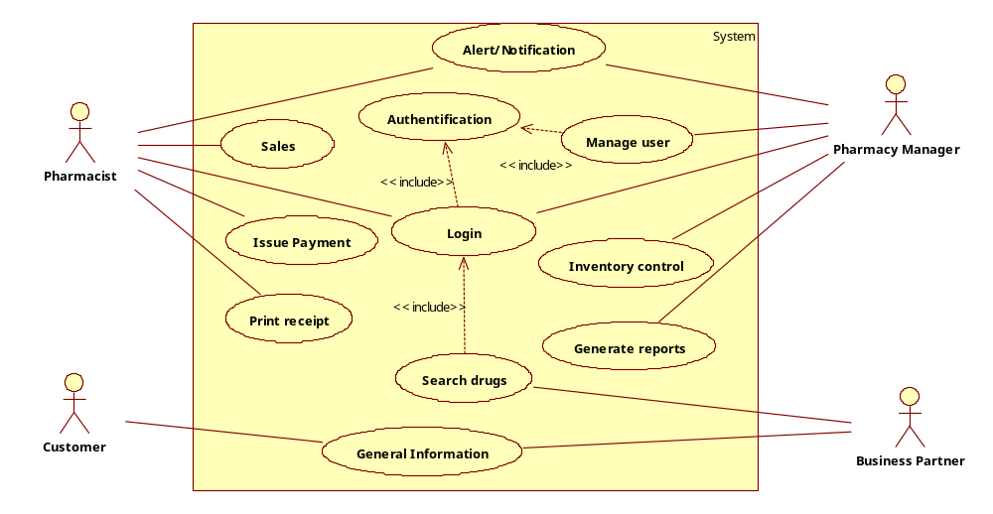
References

Houghton Mifflin, 2002. Pharmacy in Medicine. [Online]. Available at: http://www.dictionary.com/browse/pharmacy [Accessed: 5th June. 2016]
Belew Godano, et al., 2015. Pharmacy Management System. [journal] Available at: http://www.slideshare.net/HabtamuAsmare/pharmacy-management-system-requirement-analysis-and-elicitaion-document [Accessed: 5th June. 2016]

